Homework 4

1. Protecc is a home security system that is designed to keep the homeowners safe from any home-based unforeseen circumstance that may endanger their life or valuables. It is built to be monitorable through any personal device or computer and through the security system’s office. This security system includes protected windows and doors, video cameras, motion sensors, gas detectors, smoke detectors, flood detectors, and alarms. In addition to automated arming, each system can be controlled wirelessly through a personal device and can also be controlled by the security system’s employees. This includes setting the home security system to three modes, home, away, and unarmed.

The home security setting is for when the homeowners do no plan on leaving the house or tripping any of the sensors for an extended period of time because they will be inside the house. This could be during a long Saturday of rest or an overnight sleep, for example. The home security setting will make the alarm be triggered during any violation of a detector or sensor. The away security setting is for when the homeowners are leaving their house unattended for an extended period of time. This could be for a vacation or trip to a daily job. The unarmed security setting is for when the homeowners do not find it necessary to keep the security system armed and tripping certain sensors will not cause an alarm. Gas, smoke, and flood detectors will remain on regardless of the security system being armed or not and will trigger alarms when necessary. The security system’s video cameras will also run nonstop and can be viewed at any time on the homeowner’s personal device or from the security system’s office.

In order to set the system to home mode, a user must arm their system using the home’s security control panel. When in home mode and an alarm is triggered, the only way to turn the alarm off is to access the control panel and enter the appropriate credentials. Regardless of if these credentials are entered, the homeowners will receive a phone call from the office of Protecc asking if everything is alright and ask for the necessary credentials. To set the system to away mode, the homeowner can either use their personal device or use the home’s control panel. The user will have thirty seconds to leave the house before the security system is armed. When returning home, the homeowner will may set off the alarm when entering the home, causing the system to begin to go off. They will have thirty seconds to disarm the system before the alarm goes off and the Protecc officers are notified. The homeowner may use their personal device to disarm the system before entering the house. Any time the system is shut off it is automatically placed in the unarmed mode.

To trigger an alarm, the system must be set to either home or away. While armed, an alarm will go off if either a door or a window is opened. If motion is detected by a sensor, the information is sent to both the homeowner and the security system’s office to be reviewed. Any gas, flood, or smoke detectors will trigger their own alarms and will trigger the overall system’s alarm only if the case is severe. If the system is in away mode when these are triggered, the proper law enforcement agency will be notified if deemed necessary by the system. Any triggering of any detector or sensor is sent to the homeowner’s personal device to allow nonstop viewing and protection. If the homeowner deems it necessary, they may trigger the alarm remotely through their device.

If the Protecc offices are notified of an alarm and are unable to receive proper credentials from the homeowner, they police are notified immediately. These credentials include the homeowner’s designated password that they create when they buy their system. This homeowner must say this exact password to prevent the Protecc office from calling law enforcement to check out the house.

This security system can make the difference in keeping someone safe. Protecc offers homeowners constant systematic monitoring of their home while letting them personally engage in ensuring their safety. This makes the users feel safe by actively letting them participate in protecting their home.

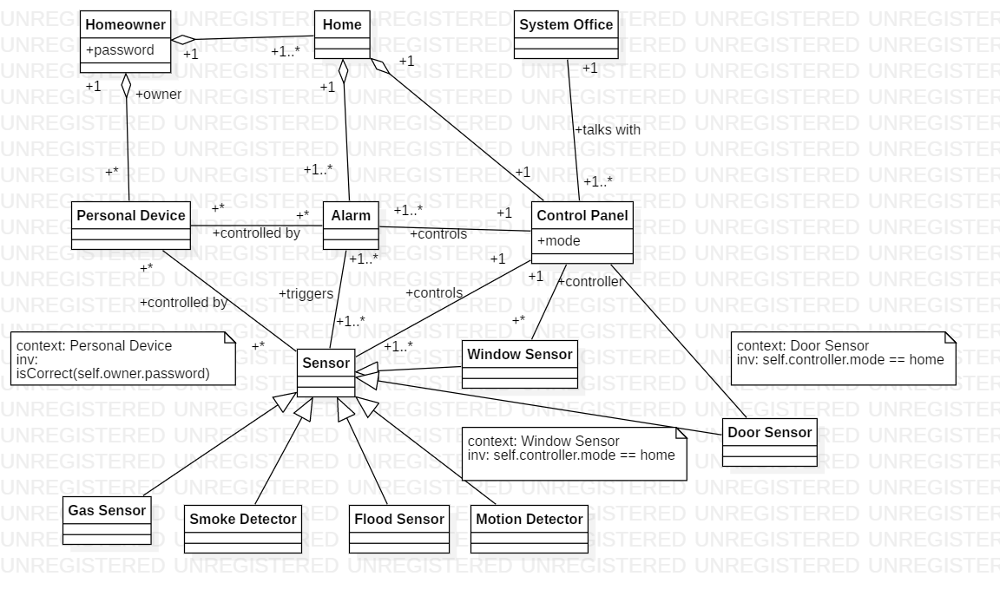



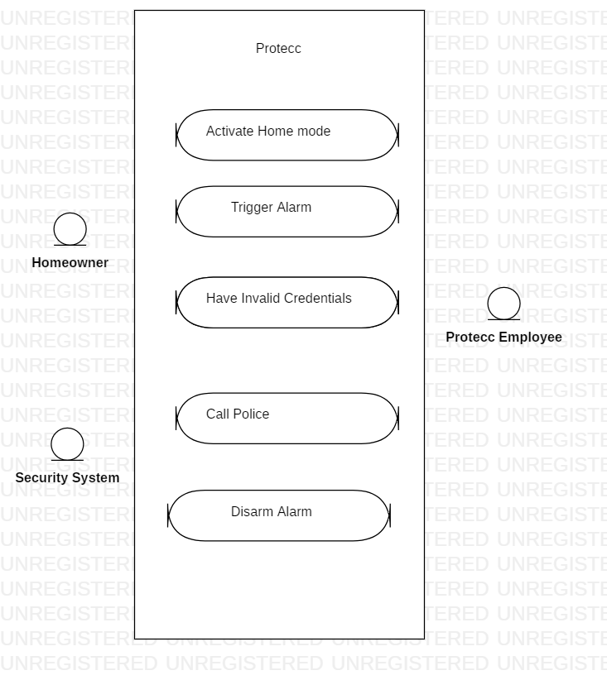

uses







Use Case Name: Activate Home Mode

Pre-Condition: The System is connected to the server and the homeowner is able to access the control box with the correct information.

Actor Intentions System Responsibility

1. Homeowner approaches the control box, prepared to enter the necessary information. This information includes what mode is desired and what the password is.
2. The Homeowner enters a password.
3. The Homeowner selects the Home mode and activates it.

3. The password is verified by matching the entered information of the homeowner to the created password of the homeowner.

4. The system grants the user access to select the system’s mode.

6. The system sets all required security appliances to the Home mode settings.

Post Condition: The Homeowner is notified that the system is now in Home mode.

Alternative Courses:

* Step 3: The password was invalid, so the system must cancel the process and reset the system to the original mode.
* Step 5: The Homeowner cancels the mode select process, and the system must reset to the original mode.

1. Scenario 1

Jane Doe turns on her control panel.

System connects with the security system.

System asks for password.

Jane Doe enters correct password.

System checks password in database.

System verifies password.

System asks for mode select.

Jane Doe selects Home mode.

System changes security system to Home mode settings.

Jane Doe turns off control panel.

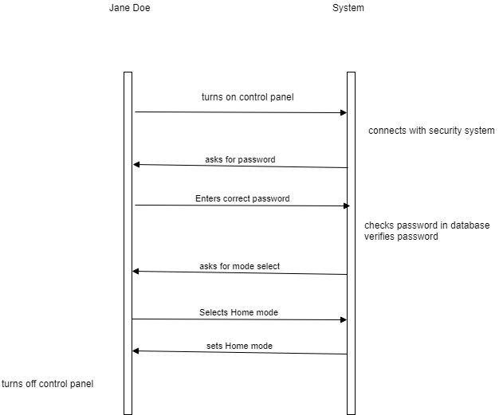

Scenario 2

Jane Doe turns on her control panel.

System connects with the security system.

System asks for password.

Jane Doe enters incorrect password.

System checks password in database.

System sees password is invalid.

System displays that the password is invalid.

System shuts off.

